1. **Product model:** GIV-Dongle
2. **Name and address of the Authorised representative:**

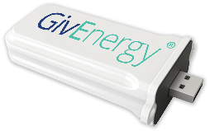

JMHing power Ltd

Unit 5 Towerhouse lane

Towerhouse industrial estate

Hedon

HU12 8EE

Telephone No. 01377 252874

1. **This declaration of conformity is issued under the sole responsibility of the manufacturer.**
2. **Object of the declaration:**

Equipment: 2.4GHz Wi-Fi Communication Device

Brand name: GivEnergy

Model/type: GIV-Dongle

1. **The object of the declaration described above is in conformity with the relevant Union harmonization legislations:**

**Radio Equipment Directive 2014/53/EU (RED)**

The radio equipment directive 2014/53/EU (RED) establishes a regulatory framework for placing radio equipment on the market.

1. **References to the relevant harmonised standards used or references to the other technical specifications in relation to which conformity is declared:**

|  |  |  |  |
| --- | --- | --- | --- |
| RED 2014/53/EU: | | EN 301 489-1 V2.1.1  EN 301 489-17 V3.1.1  EN 300 328 V2.1.1  EN 62311:2008 | |
|  | |  | |  |  |
|  |  | |

1. **Signed for and on behalf of:**

Authorised representative:

JMHing Power Ltd

Unit 5 Towerhouse lane

Towerhouse industrial estate

Hedon

HU12 8EE

Telephone No. 01377 252874

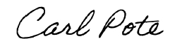

________________________________________

Carl Pote- Head of European operations

Burton on Trent, Staffordshire (05.06.2019)